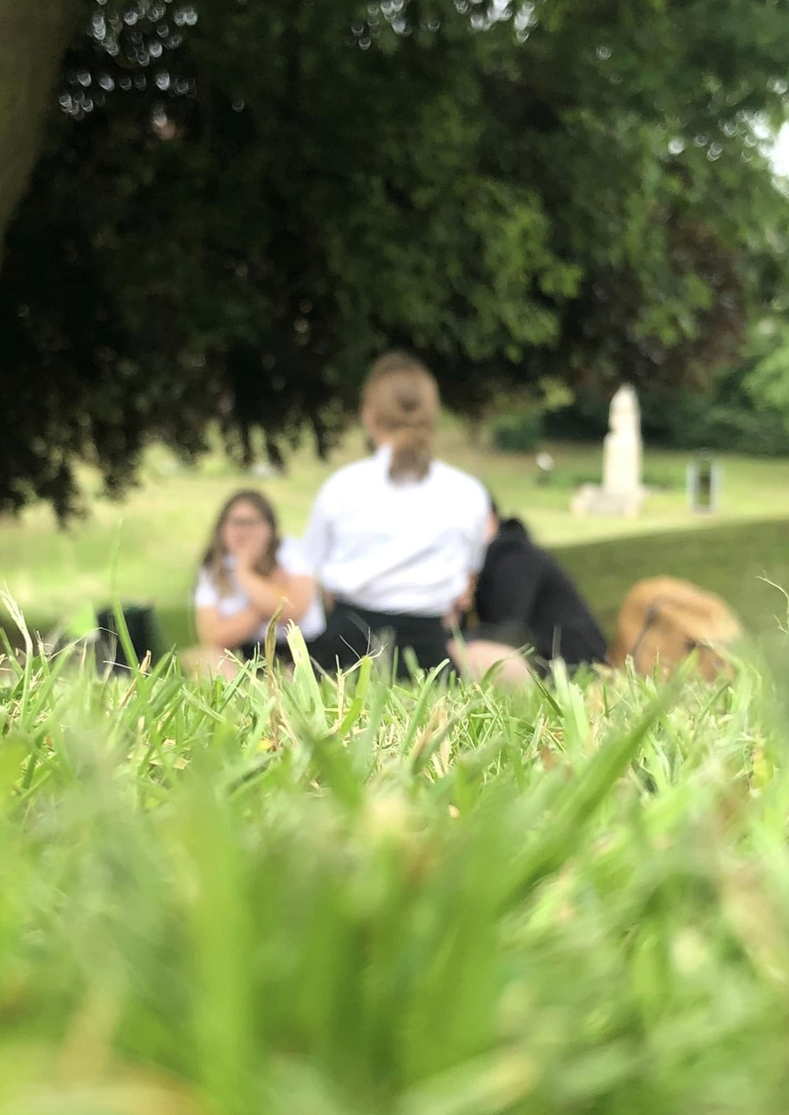
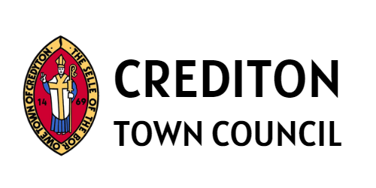



PEER EDUCATOR - (PROJECT BASED)

Recruitment Pack - December 2025

To the applicant

Thank you for your interest in applying for the position of Peer Educator (Project Based) with Crediton Town Council (CTC).

This recruitment pack has been designed to provide you with more information about the role and us as an organisation.

Please note that we will only consider applications that are submitted using our application form - CVs will not be accepted.

Please apply by email for my attention, to r.avery@crediton.gov.uk on Sunday 4th January 2026.

If you would like any further information or wish to discuss the role and our organisation further, please contact Cath Kelly (Lead Youth Worker) on 01363 773717 or c.kelly@crediton.gov.uk.

Racttel Avery

Rachel Avery FSLCC Town Clerk

About us

Crediton is a thriving market town, situated in Mid Devon.
Crediton has 8,070 residents (as at the 2021 census).

Established in 1972, CTC is the most local level of government to the town, working alongside Mid Devon District Council and Devon County Council to deliver public services.
We achieved Quality Gold Status in 2021, proving our commitment to progression, good governance and contribution to the community it serves.

Our town has an amazing network of organisations and groups, who are valued highly by the town council. Many are supported through our annual grant funding.

CTC comprises twelve elected councillors across two wards (Boniface and Lawrence), with elections taking place every four years.

Members are ably supported by a small team of officers who work to fulfil its plans, effectively delivering a range of services, projects and events to the community.

About us

Following the withdrawal of a Devon County Council funded Youth Service in 2007, councillors actively campaigned for the opening of a new youth club in Crediton. CTC created Crediton Youth Service (CYS) in 2021, supporting young people aged 10-18.

In 2022, CTC created an ambitious plan to provide a mixture of centre-based, detached and outreach youth work, following consultation with residents which identified a need for activities for young people, including the opening of a centre-based youth club at Old Landscore School in March 2022.

Throughout 2022 - 2024 CYS delivered a varied programme, with our Youth Club opening on a Wednesday and Thursday after school for years 6, 7 and 8 and in the evening for young people aged 13+.
Young people actively participated in programme planning, giving lots of ideas about the types of activities they would like to be at the Youth Club, including arts, crafts, music, indoor and outdoor gardening, sustainability, developing a small outdoor games area, sewing and textiles, cookery and baking, board games, DND, film nights and trips out.

The service was run by our Lead Youth Worker and supporting sessional workers, based at Old Landscore School.

About us

In November 2024, Old Landscore School closed for redevelopment and youth activities were relocated mainly to community settings such as Crediton Library and Crediton Arts Centre.

CYS launched its Strategic Plan in 2024, which sets out clear objectives for 2024 to 2027. We want to create strong and meaningful networks to enable young people to enjoy their town, thrive during their formative years and become well-rounded, active members of our community.

The Youth Strategic Plan has 4 key objectives:
- To provide youth activities, projects and opportunities in Crediton
- To foster and develop increased learning and development opportunities for young people by encouraging and supporting them to contribute, steer initiatives and lead their own youth-led projects
- To work in partnership with the wider community, health and education organisations and other relevant groups that align with our aims and objectives
- To generate a sense of responsibility and ownership in young people through social action and to develop their citizenship and involvement in their communities.

About us

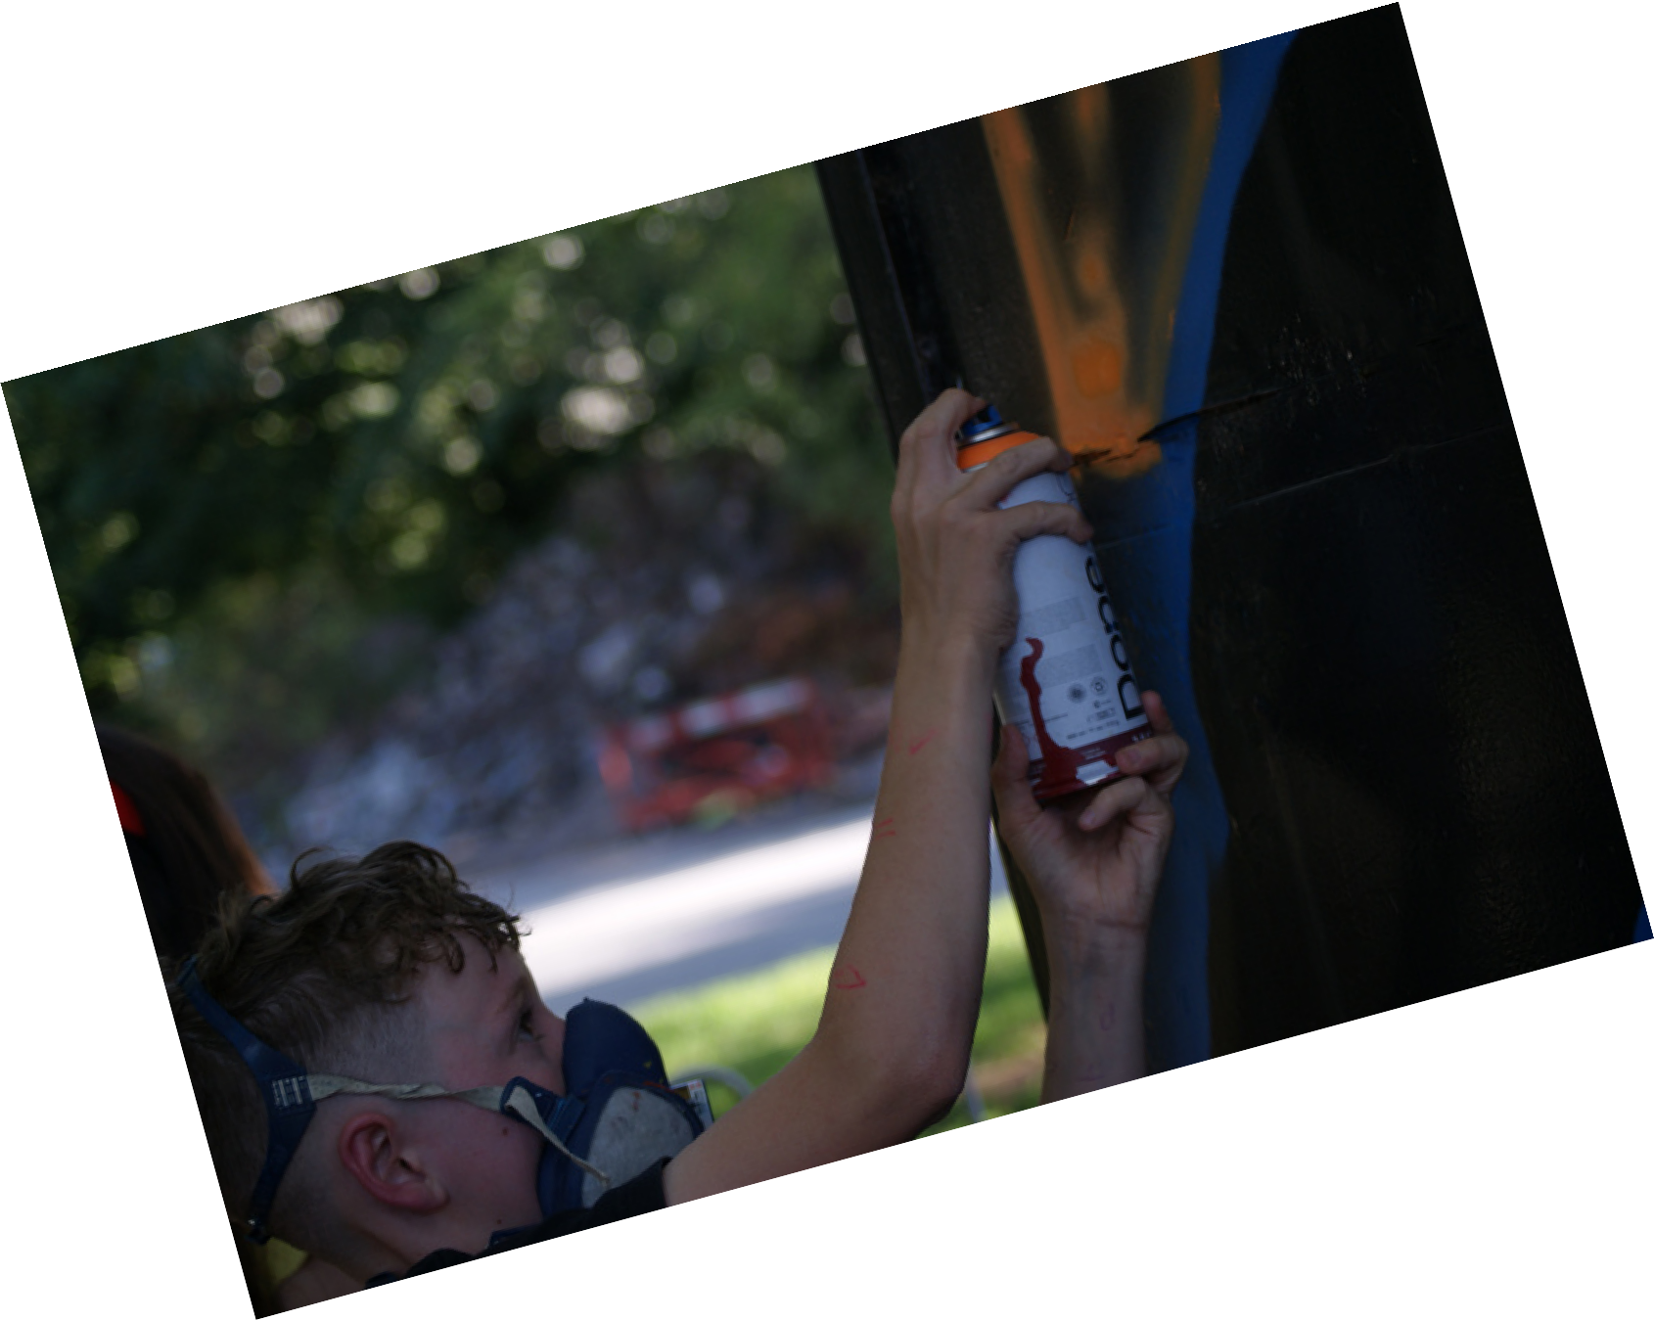
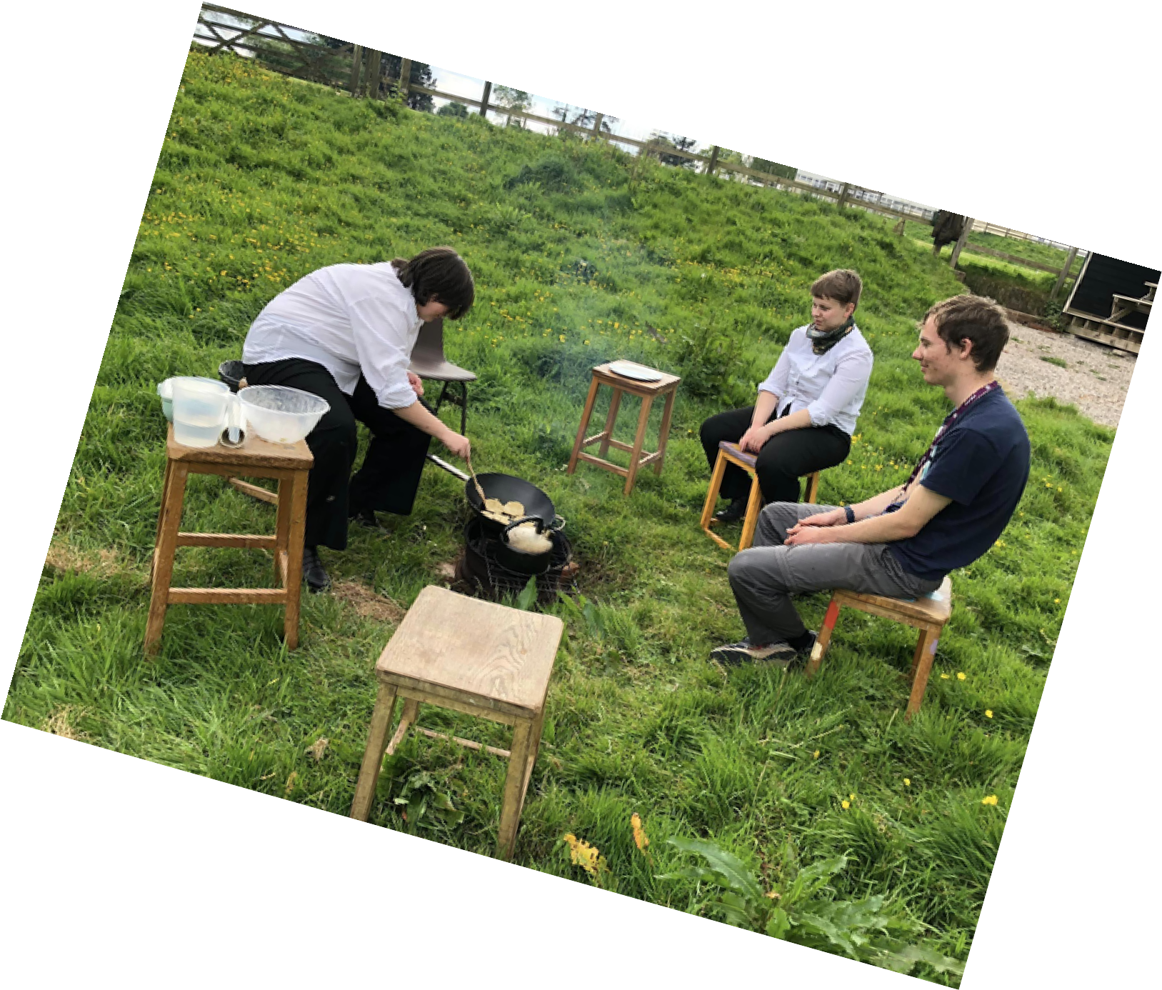


From August 2025, CYS will be working towards these objectives through the provision of project-based youth work, both weekly and longer term, including increasing our partnership working, establishing a youth council, delivering work with girls and LGBTQ+ young people, and increasing our internship and work experience
offer.

About the role

We are looking for Youth Work Peer Educators to help us run an ambitious project-based programme.

These Youth Work Peer Educators posts will suit young people who want learn youth work skills, develop good employability skills and experience in project-based youth work, and who want to make
a substantial difference for young people in our community.

Applicants will need to meet all the essential requirements of the post, as well as demonstrate additional skills that will support one or more project areas.

Each area of work is described below. Posts may be combined for the right applicant. Salary is dependent on experience and qualifications – please see below.

You will need to be able to work as part of a team, as directed and have excellent communication skills.

This role will include evening and weekend work as most of our youth work take place outside of office hours.

Working for us
You will work as part of a small team and your manager (the Lead Youth Worker) will work alongside you and be available to support you with your youth work delivery.

As an employer, we are committed to developing the skills of our team and ensuring professional and personal growth in the form of continuous development.

You will be required to attend staff meetings. These may focus on problem solving, actions, development or team building, as well as curriculum planning and developing a youth work programme.

CTC's staffing structure is as follows:

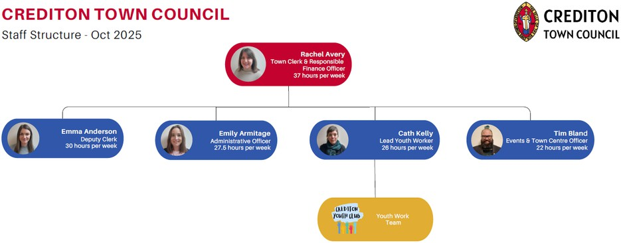

Job Description

You will be:

Working with young people aged 10+
Learning about workplace policy and procedures
Working collaboratively with Crediton Youth Service youth workers
Promoting the voice and influence of young people Creating and having fun
Helping young people achieve their potential.

About You:

You will be a school leaver, aged 16 to 21 (current year 12, or older), and interested in gaining youth work skills

Communicating with people – including people you don’t know Working well together – supporting your team
Creative and skilful - having ideas and trying new things Organised and thoughtful - positive work ethic
With hobbies or interests you might want to share with others.

Job Description (continued)

Crediton Town Council is continually striving to be an inclusive organisation. Equality, diversity and inclusion are threads that run through all our work, and should run through all our relationships with colleagues, stakeholders, partners and all those we work with. We go beyond the approach described by the Equality Act 2010 and choose to take an anti-oppressive approach to our work and how we behave as an organisation.
We encourage applications for this role from all backgrounds in respect of ethnicity, age, disability, gender, sexuality, religion and socio-economic background.

If you are still in full time compulsory education (current Year 11), we are sorry, but we will be unable to employ you at this time. Please check back again when you have left school, we are able to be flexible around Sixth Form / FE timetables.

If you are still in full time education, but interested in volunteering for us, please do get in touch, we have lots of accredited volunteering opportunities available.

Person Specification
The person specification will be used to assess whether you are the right person for the role. We will use these criteria to assess your application form to shortlist for interview.
We want to support the broadest range of applicants. Please contact Cath Kelly if you would like further support understanding the application process and the requirements of the post.
Requirement

Education/Training

Skills and knowledge

Experience

Personal attributes
Essential

GCSE (or equivalent) at C/4 or above for English, or just completed study at GCSE level or equivalent.
Good mathematical understanding (demonstrable through interview process).

An understanding of the issues affecting young people both nationally and in Crediton.

Good written and verbal communication skills.

Good ICT skills and organisational skills.

Experience of working in a team eg in an education or extra curricular setting such as sports club or Duke Of Edinburgh.

A flexible and enthusiastic approach.

Creative and skilful - having ideas and willing to trying new things.
Desirable

GCSE (or equivalent) at C/4 or above for Maths, or just completed study at GCSE level or equivalent.
Commitment to achieving Level 2 Youth Work qualification in a negotiated time scale, (including some voluntary hours to complete).

Willingness to train to Safeguarding Level 2.

Willing to learn about NYA Curriculum for Youth Work, and work with the Youth Work Team to deliver a youth work programme designed to meet the needs of young people.

Experience of volunteering.

Ability to make trusting and supportive relationships with young people.

Hobbies or interests you might want to share with others eg music, arts, crafts, sports, D&D, games, skateboarding.

Person Specification
In addition to the Person Specification above, please also see the Project Specific requirements. We will use these criteria to assess your application form to shortlist for interview.
Project

LGBTQ+ Bookclub

Youth Council

Girls Group

Skate Park
Essential

Passionate about reading.

Enthusiastic about promoting the voice and influence of young people.

Understanding of issues affecting girls and young woman.

Experience of skate boarding.
Desirable

Lived experience as a member of the LGBTQ+ community.

Experience of being a member of a youth council, school council or other similar group.

Commitment to supporting young people to campaign on issues that are important to them, such as skate park improvement.

Selection Process and Interviews

The closing date for applications is Sunday 4th January 2026. Late applications after this date will not be considered.

A shortlisting panel comprising of the Town Clerk and Lead Youth Worker will review each application and score it based on how well you met the essential and desirable criteria within this document.

Interviews will be held from Wednesday 7th January 2026 onwards.

The interview process will be in two parts. The interview panel will comprise the Town Clerk, Lead Youth Worker and one member of the council.
In addition, applicants will have the opportunity to meet young people and take part in an informal interview process by designed by young people involved in the youth council, and supported by the Lead Youth Worker.

General Terms of Employment
You will receive the detailed terms of employment within a written contract, issued to you prior to your start date.

TITLE:
Youth Work Peer Educator

SALARY:
Commencing on SCP 2 to SCP 3 (£24,413 - £24.796 per annum pro rata)
Depending on qualifications and experience Fixed Term Contract to March 2027

HOLIDAY:
Rolled- up holiday paid at 12.07%

HOURS OF WORK:
Minimum 2.5 hours per week per session, with the possibility of additional hours (posts may be combined)
Project based appointments may also be offered

PENSION:
You will be enrolled into the Local Government Pension Scheme

PROBATION:
Your appointment will be subject to a satisfactory probationary period of no less than 13 weeks

